Software Requirements Specification (SRS)
Project Name: NeuroFusion
Platform: Expo React Native (Frontend) + FastAPI (Backend) + MySQL (Database)
Backend Architecture: Custom Python backend using PyTorch and a custom Diffusion
Version: 1.0
Author: Jatin Nath
Date: July 1, 2025

1. Introduction
1.1 Purpose
This document defines the software requirements for a mobile-based AI-powered Text-to-Image application. The app allows users to generate images using a custom Stable Diffusion v1.5 model via natural language prompts, including image-to-image transformation, generation queuing, and user management.

1.2 Intended Audience
- Developers working on frontend/backend
- Project managers
- Testers
- End users (Admin and General Users)
1.3 Scope
The application enables:
- Secure user authentication
- Text-to-image and image-to-image generation
- Negative prompt support
- Generation queuing and cancellation
- Prompt/image history
- Admin dashboard for monitoring usage
- Real-time progress tracking via backend
- Cross-platform accessibility via Expo Go
2. Overall Description
2.1 Product Perspective
The system is composed of:
- Frontend: React Native (Expo), communicates via Axios with the backend
- Backend: FastAPI REST API with async queueing and Torch-based Stable Diffusion model
- Database: MySQL for storing users, prompts, queue items, and images
2.2 Product Functions
- User Login/Register
- Prompt Submission (Text/Image)
- Image Generation via Stable Diffusion
- Queue Management (add, cancel, track)
- View History and Queue Status
- Admin Control Panel
2.3 User Classes and Characteristics
User Type | Permissions
General | Register, Login, Generate, Queue, History
Admin | View all users, all images, monitor usage  Edit users

3. Specific Requirements
3.1 Functional Requirements
3.1.1 User Management
- Users can register/login with username & password
- User sessions are persisted
- On logout, clear generation queue
3.1.2 Prompt Submission
- Text-to-Image input with:
  - Prompt
  - Negative Prompt
- Image-to-Image input with:
  - Initial Image (base64)
  - Prompt and negative prompt
3.1.3 Generation Queue
- Async generation queue handled by FastAPI with asyncio.Lock
- Only one generation is processed at a time
- Each queue item includes:
  - User ID
  - Prompt
  - Type (txt2img or img2img)
  - Optional image
- Cancel queued prompt by user
- Cancel active generation mid-way
- Track queue progress (via tqdm)
3.1.4 History & Display
- On completion, generated image stored with prompt & timestamp
- Display all completed prompts on "MyQueue" screen
- Store in MySQL: images, prompts, users, queue
3.1.5 Admin Panel
- View all registered users
- On selecting a user, view:
  - All their prompts
  - Generated images

3.2 Non-Functional Requirements
3.2.1 Performance
- CPU and GPU inference support
- Prompt response time ranges from ~4 to 6 minutes based on GPU compatibility and hardware performance
- Queue must maintain sequential processing even with concurrency
3.2.2 Scalability
- Backend designed to handle 100+ concurrent users
- Future support for distributed inference (optional)
3.2.3 Usability
- Mobile UI optimized using Expo
- Scrollable history
- Input validation (empty prompts, large images)
3.2.4 Reliability
- Handle queue crashes gracefully
- Prevent duplicate prompts
- Ensure cancelling generation doesn’t leave locks hanging
3.2.5 Security
- Input sanitation
- Image size/type restrictions
3.2.6 Maintainability
- Modular codebase with separation of concerns (Frontend, Backend, Model)
- Dockerized backend for consistent deployment
- Use of logging and exception tracking for debugging and uptime
3.2.7 Portability
- Frontend runs on Android, iOS, and Web via Expo
- Backend deployable on any machine supporting Python and CUDA
- Model weights and configs externalized for replacement or upgrades

4. System Models
4.1 ER Diagram
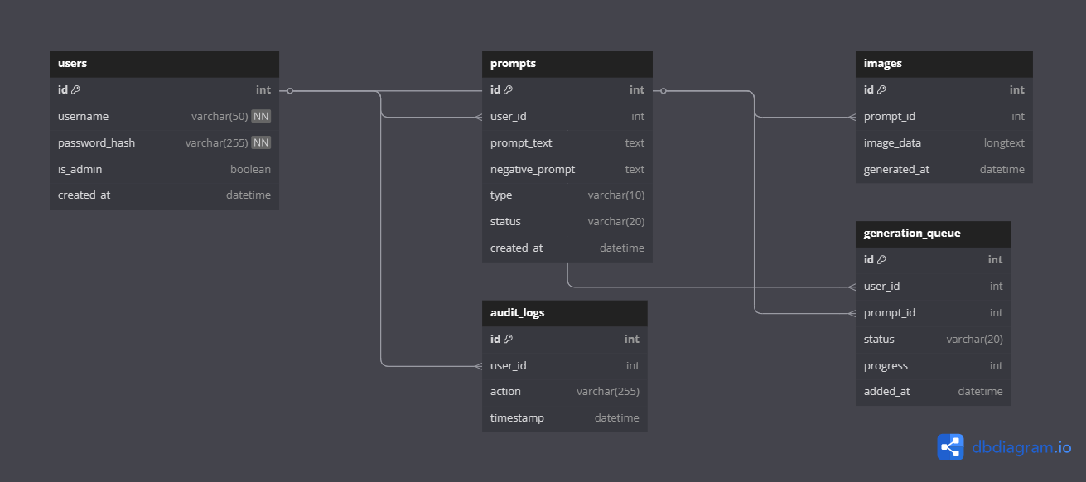

4.2 Use Case Diagram
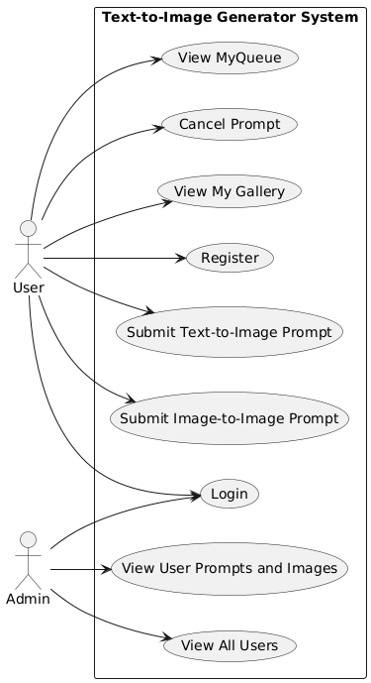

5. Appendices
5.1 Glossary
Term | Definition
Prompt | The input text used to generate an image
Negative Prompt | Specifies what the image should not contain
Img2Img | Image-to-image generation using initial base image
Queue | System managing multiple prompt submissions
CLIP | Contrastive Language–Image Pretraining model

5.2 Future Enhancements
- Support for multiple concurrent generations using GPU batching
- Feature to share generated images via social media
- Style presets or templates (anime, realistic, abstract)
- User profiles with favourites and private/public image collections
- Support for multilingual prompts and translation
- Server-side caching for repeated prompts

